**Approximate Mockup for your application, description and HomeTask.**

The idea behind this, is that you are making sort of news aggregator (portal), based on a NewsAPI (the one from your previous task a).

You can choose any design for the template, change a structure as you like, but try to stick to the following points:

1. Make a source name, e.g BBC as a heading, after you choose the one from the list (2). If the source is your own database, hide source name or display the name you choose for your portal.
2. List of sources from NewsAPI, ad in first task. After you choose one or another from dropdown, the news-articles list updates according to the source. Source Name also updates. It would be a plus if you will add an option like ‘all sources’, when all news from all the sources will be shown without selecting any specific.
3. Filter: type a few words, and list of news should be filtered by keywords once you click on filter
4. Add article – redirects you to the creation page.
5. Newsline. This is shorten news-article. Contains an image and short description. After a click on it – redirects to the appropriate page of an article, with full text. See picture at the last.

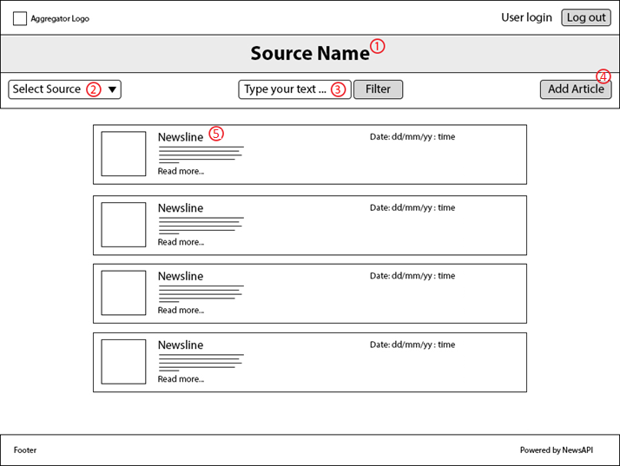

Note: Ignore the Filter Functionality – point 3

This is Create, which will be working with your API, that you’ve done on the previous covered topics.

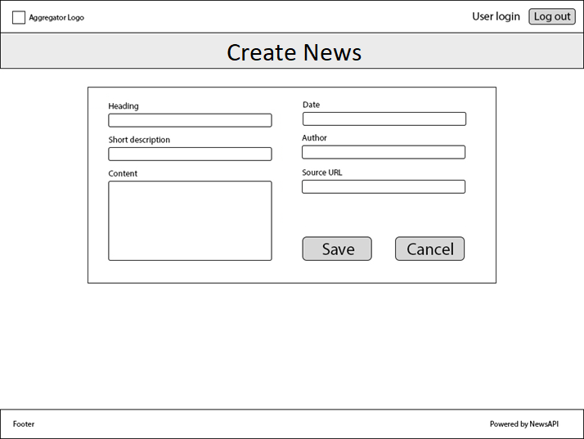

Homework for Part1:

1. In the existing sample application, do the following
   1. Cross Component Communication using Service
   2. Ng-content to populate the component data
   3. Subject Implementation
   4. Use pipe for formatting the date
   5. Fetch the data using Angular HTTP Client
2. Create a separate sample project and implement all the interfaces of a component life cycle
3. **BONUS**: It would be great if you implement any custom observables